Thomas Rafeld, M12808058

Ryan Winterhalter, M12727389

Lab 10 Report

**Objectives:**

The objectives of this module were to be able to describe a graph, understand the approaches to store edges and vertices of graphs, and build a graph. The first objective of being able to describe a graph is important to this course, as being able to describe the data structures is an important part of understanding how the structures work. We need to be able to understand how graphs work for this lab, as the whole purpose of the lab is to implement a functioning graph. This would be important to a career in engineering as we would need to be able to describe and understand the graph if we needed to use one in a project. The second objective in understanding approaches of storing edges and vertices is important to our success in this class as we need to understand the approaches in order to use them in this lab, as well as to fully understand the functionality of the type of data structure that we are learning. It would be important to a career in engineering if we needed to use a graph for a certain implementation. Being able to choose the appropriate implementation of the graph that would be best for the project we were implementing it for would be critical to our success on this project; if we didn’t understand the different approaches, we would not be able to implement the graph with the best approach. The final objective of being able to build a graph is important to our success in this course because we needed to be able to build the graph for this lab. Additionally, the purpose of this class is to learn about and be able to implement functioning data structures, so being able to build the graph shows that we have learned how the structure works. This objective is also important to a career in engineering because we may be asked to build a graph for a project on which we are working, so being able to do so would be essential. Additionally, being able to construct a functioning graph is important to our success in engineering because a career in engineering is all about being able to produce a functioning solution. Being able to understand graphs is one thing, but a career in engineering would require us to apply that understanding to make a functioning product that performs a certain task. Therefore, being able to build functioning graphs is essential to a career in engineering.

**Task 2:**

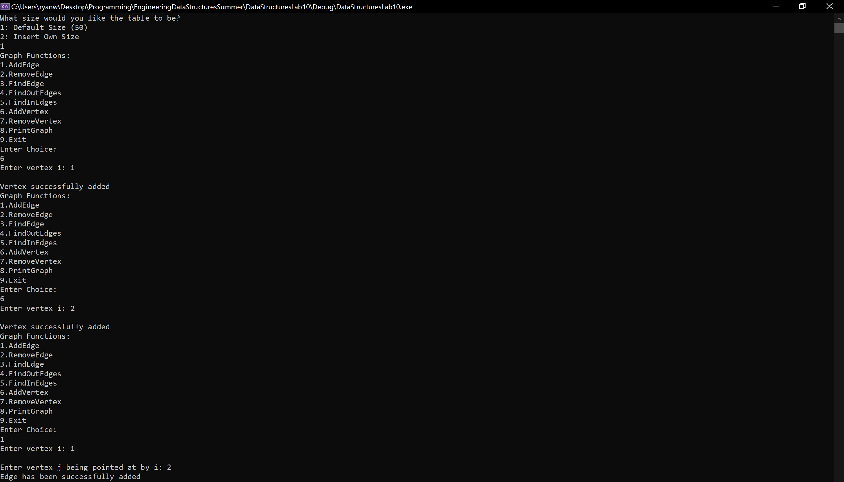

Figure 1: Screenshot showing functionality of AddVertex and AddEdge functions

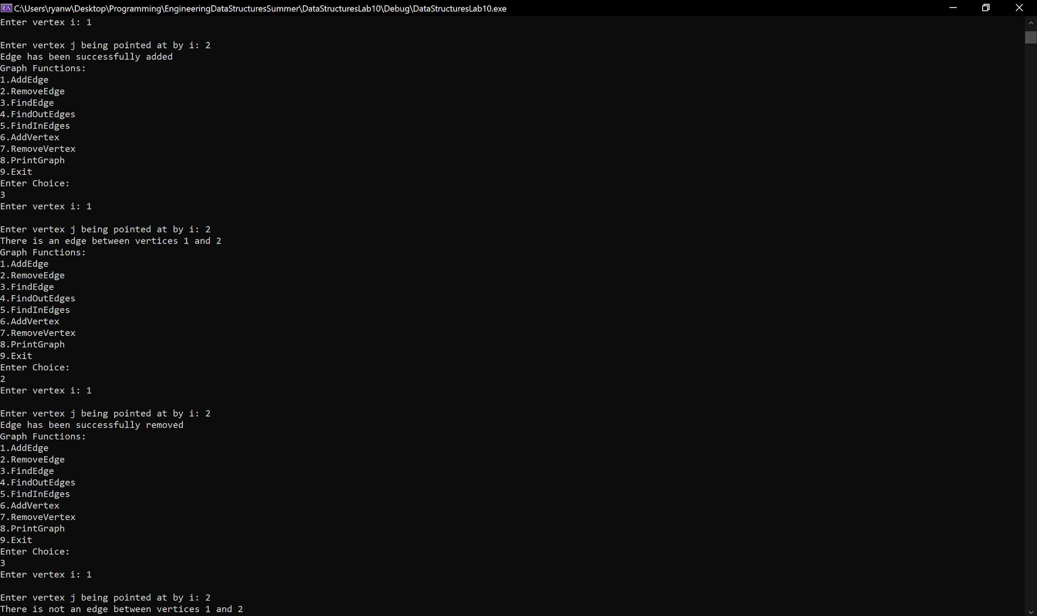

Figure 2: Screenshot showing functionality of HasEdge and RemoveEdge functions

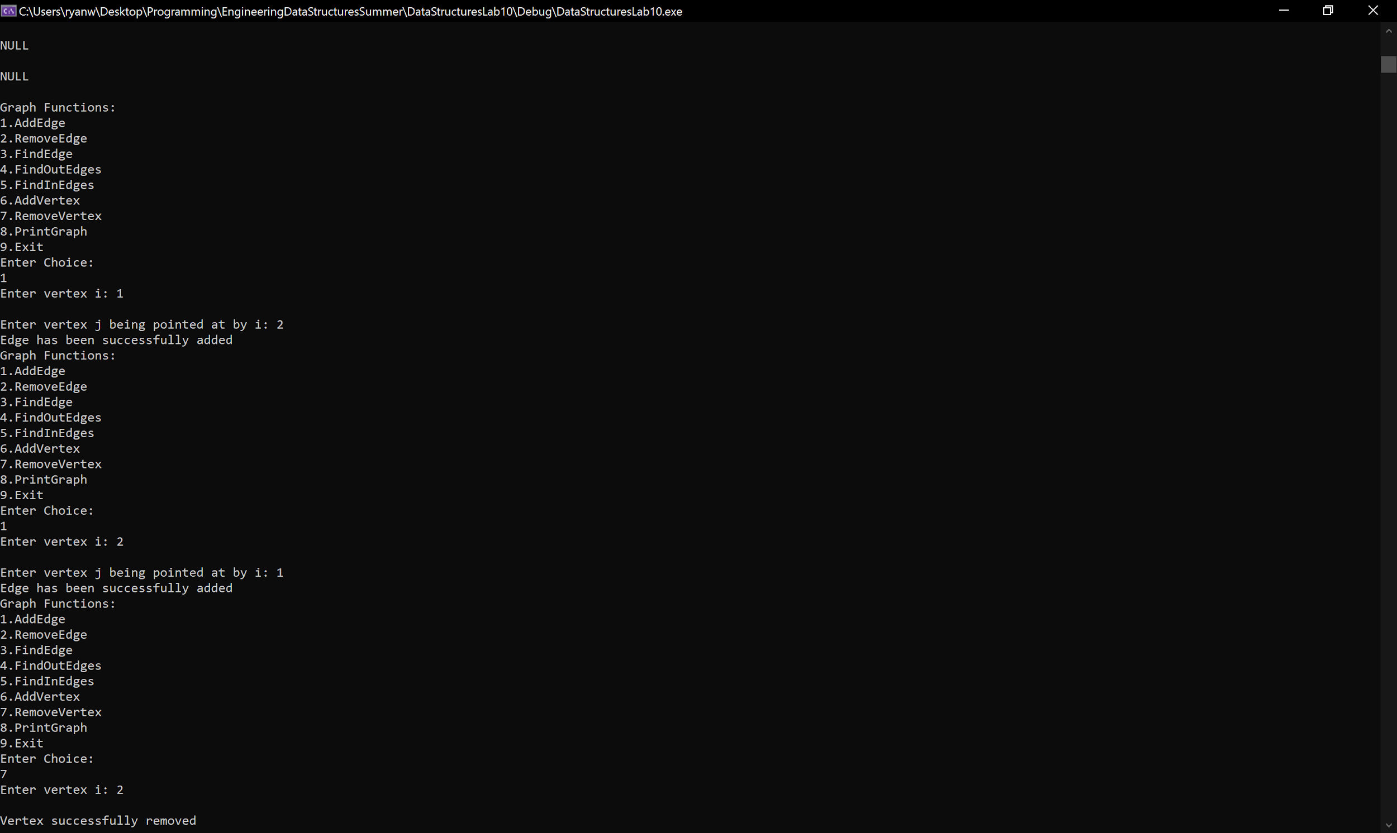

Figure 3: Screenshot showing functionality of RemoveVertex function

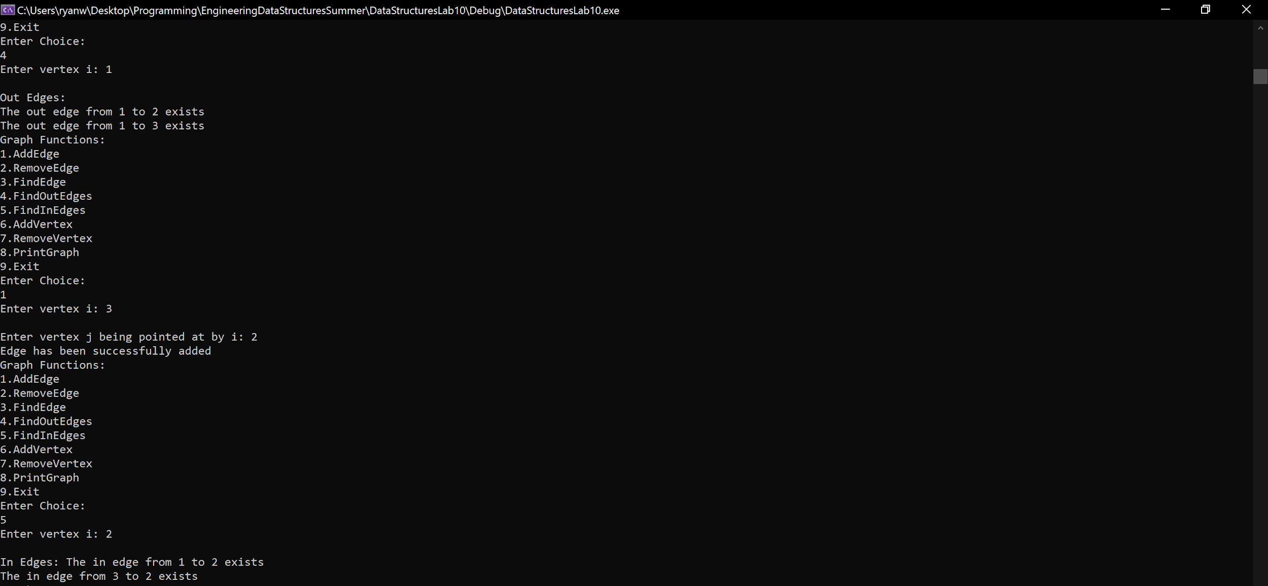

Figure 4: Screenshot showing functionality of InEdges function

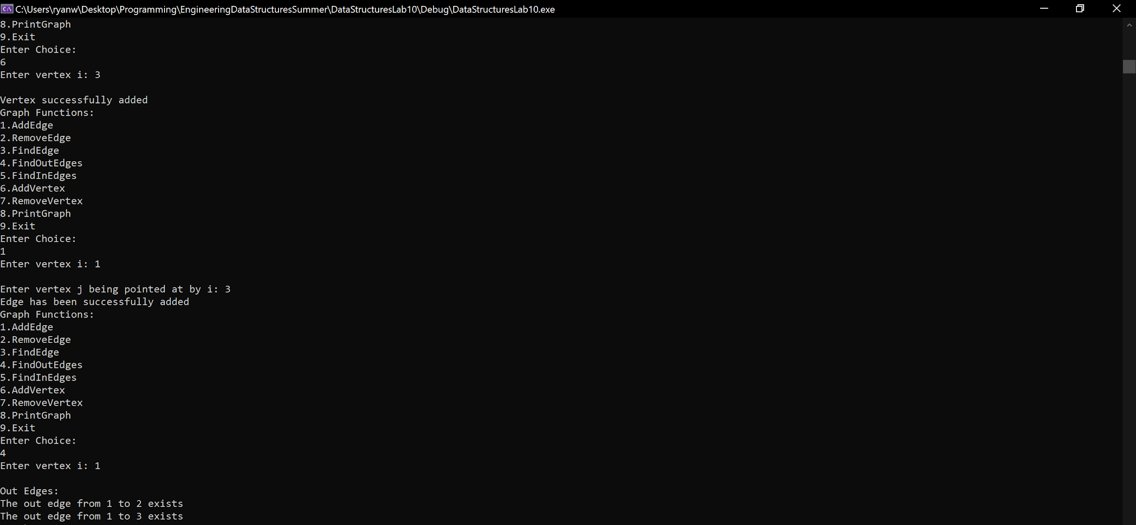Figure 5: Screenshot showing functionality of OutEdges function

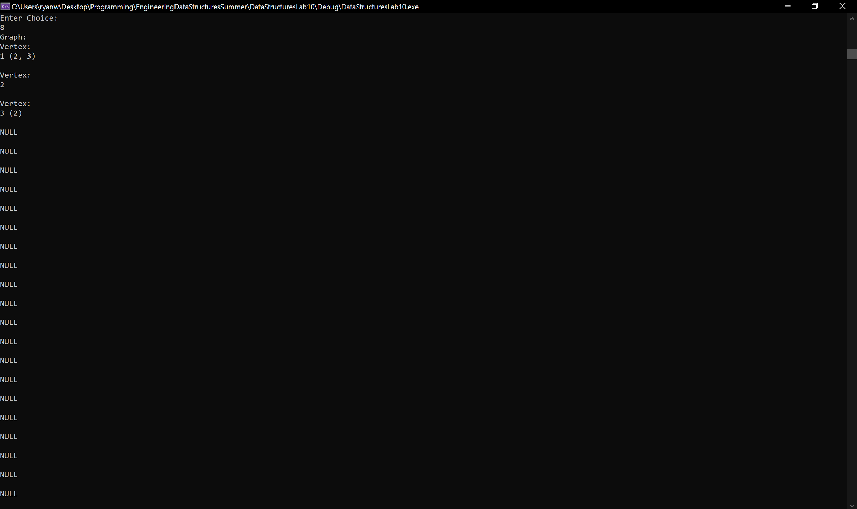

Figure 6: Screenshot showing functionality of PrintGraph function

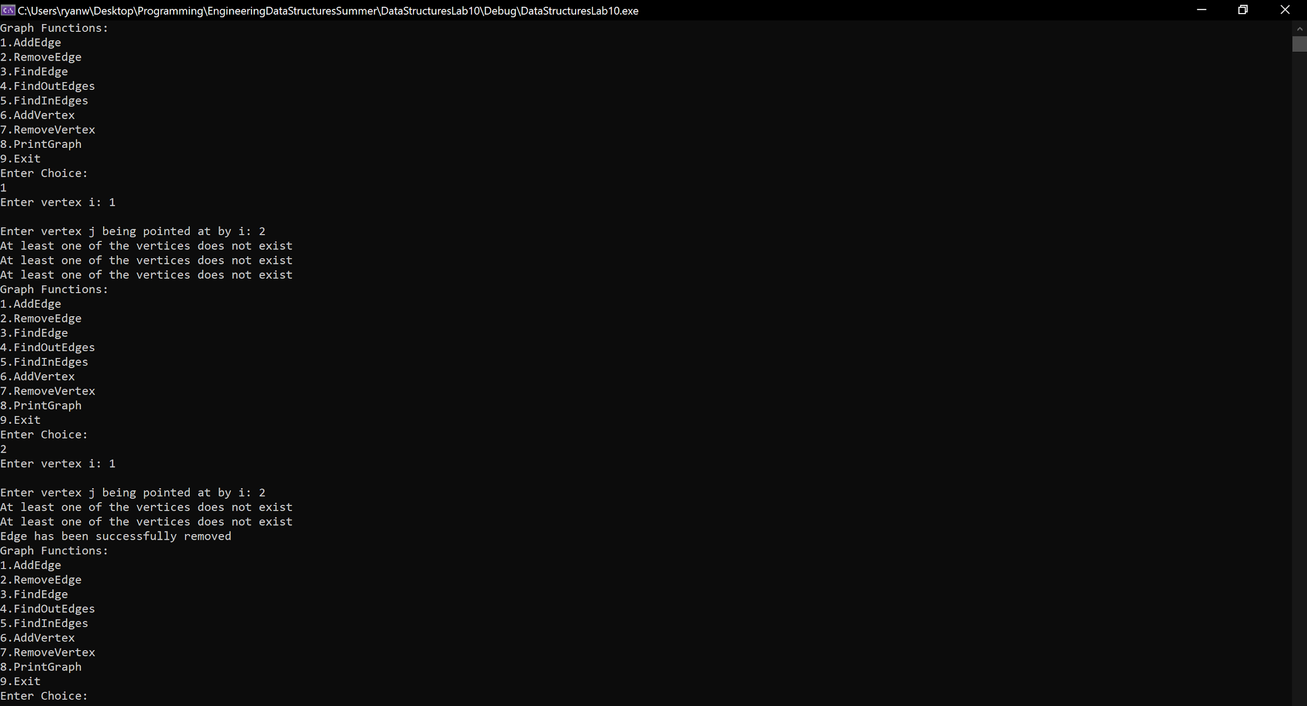

Figure 7: Screenshot showing negative cases of addEdge and removeEdge functionality

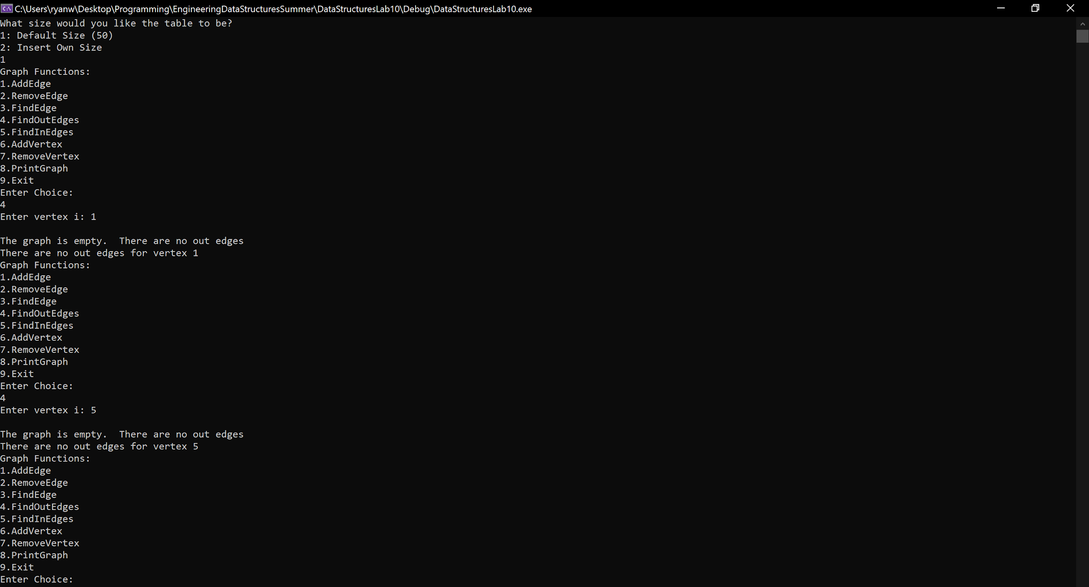

Figure 8: Screenshot showing negative cases of inEdges and outEdges functions

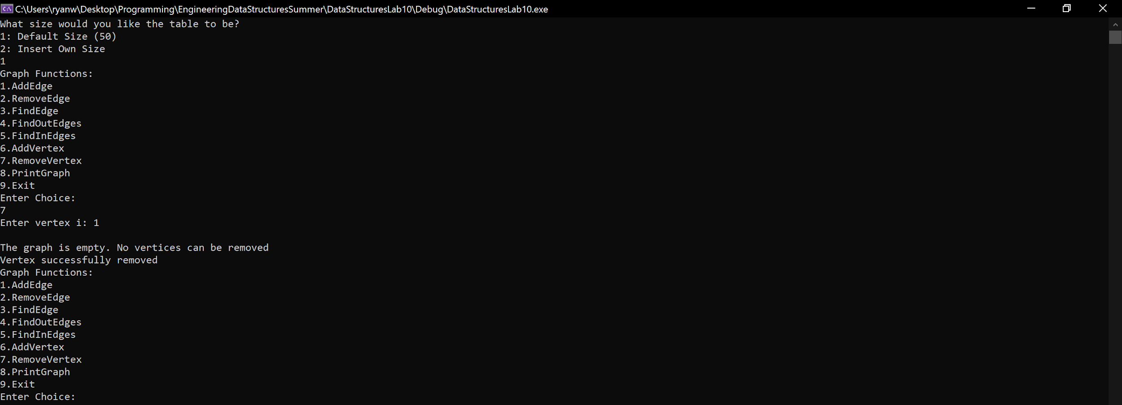

Figure 9: Screenshot showing negative case of removeVertex function

**Task 3:**

Screenshots of graph of U.S. states (continued onto next page).

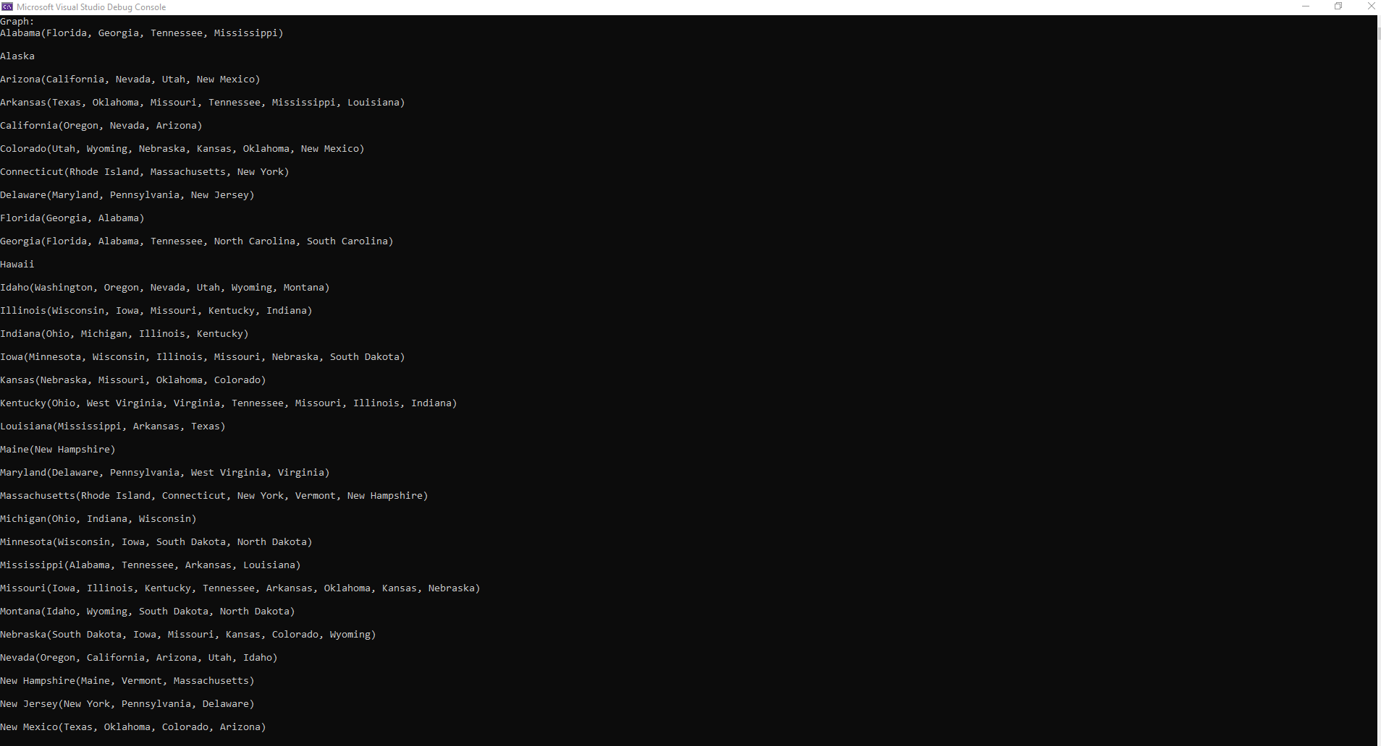

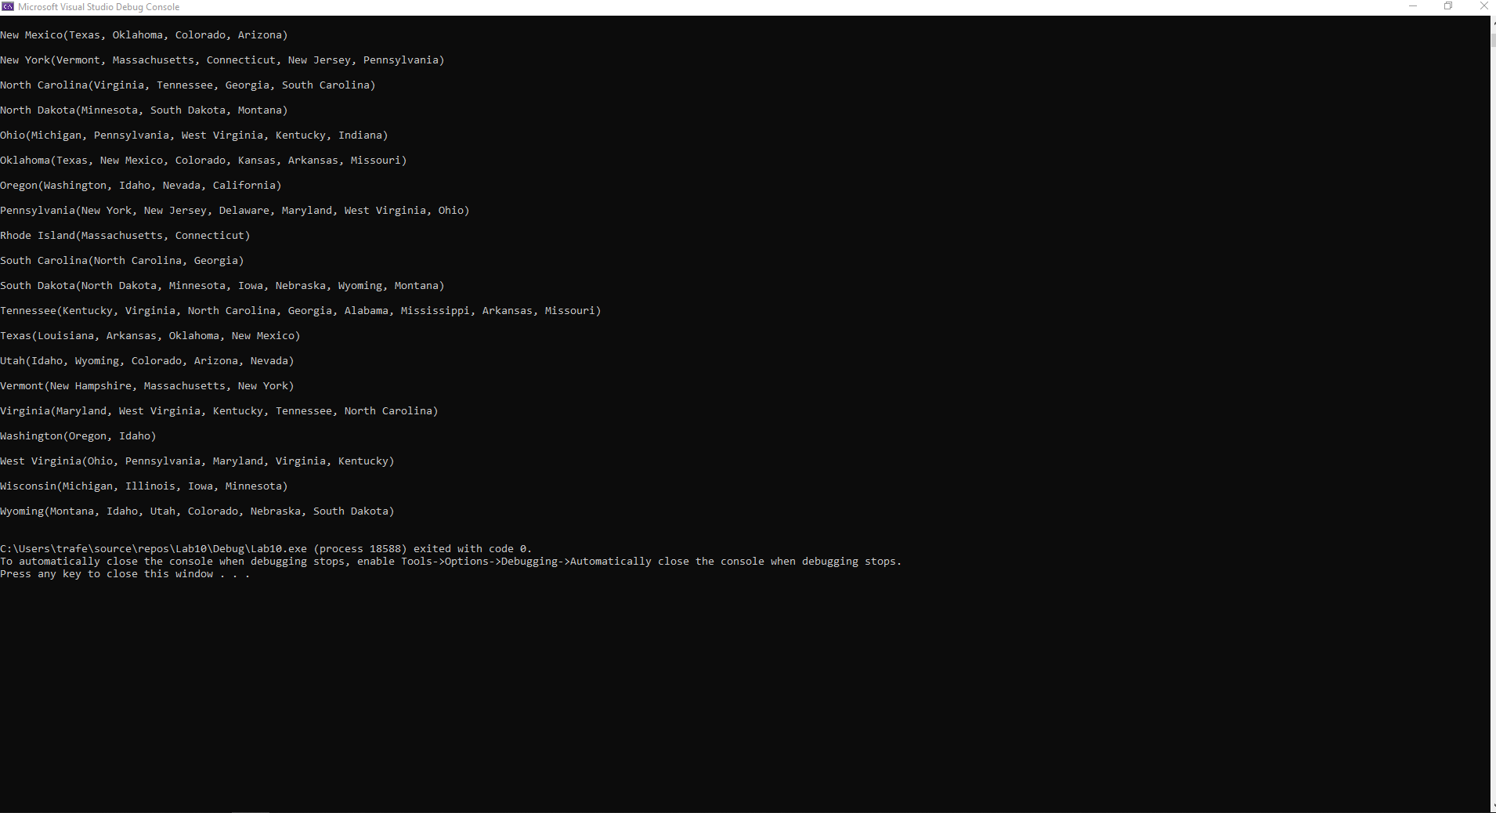

**Group Contributions:**

The lab was worked on together by both Ryan and Thomas while on a call together in Microsoft Teams. For tasks 1 and 2, we worked together to write all of the member functions and our testing ‘.cpp’ file, and we used Thomas’s files for those tasks. For task 3, we worked together to modify our header from task 1 to work for strings instead of integers and to write our testing ‘.cpp’ file, and we used Ryan’s files for those tasks. For the final grade each member of the group should receive 100 percent of the grade as we feel that we both evenly contributed to the lab and worked together for almost the whole time it was being worked on.